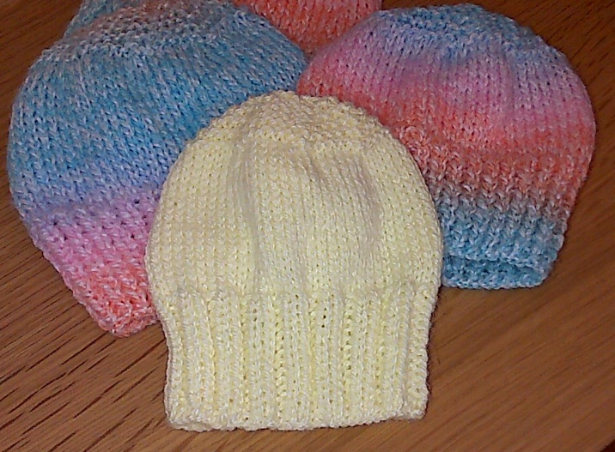

**Baby Beanie Hat**

**For ages 0-1yr**

*The sizes of this hat will vary depending on the size of needles used and the gauge of the wool used but this isn’t too important as babies come in all sizes.*

Using DK wool and 4mm needles, cast on 64 sts and work 14 rows in k1,p1 rib (or k2,p2,rib if you prefer).

Work 18 rows in st.st or until work measures 11cm from cast on edge.

Shape crown:

Row 1 *k6, k2tog. Repeat from * to end of row (56 sts)

Row 2 and every alternate row: Knit

Row 3 *k5, k2tog. Repeat from * to end of row (48 stitches)

Row 5 *k4, k2tog. Repeat from * to end of row (40 stitches)

Continue decreasing in this manner until (k1, k2tog) has been completed and 16 sts. remain

Knit 1 row. Break yarn and thread through remaining 16 sts.

Pull up tightly and join seam.